Topic- ADHD and Autism

Color scheme- Pastel yellow, dark blue, baby blue, sky blue

EQ- How can we develop a knowledgeable website that educates our community to increase

acceptance and spread awareness about people with ADHD or autism?

DQ- How can Year 7 Indigo create a knowledgeable website which establishes a smart, safer, and valuable society for all generations?

Total page numbers-7 pages

**Wireframes:**

**Homepage**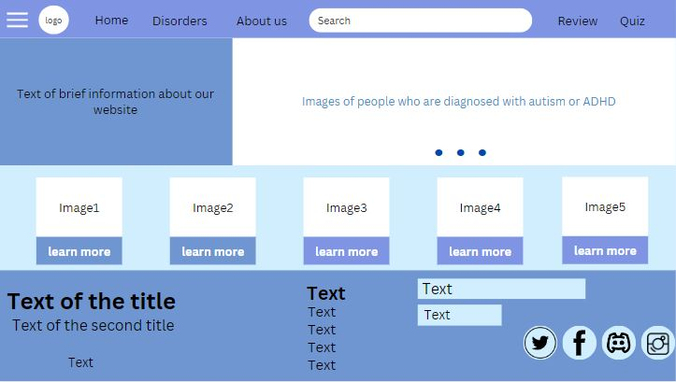

**Homepage**

**ADHD page**

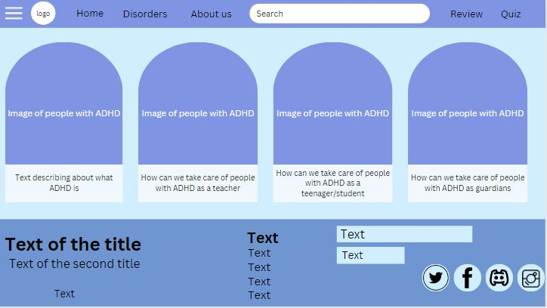

**Reference links:**

<https://youtu.be/oLgtucwjVII?si=tVxCLiIV8WvPx_3u>

<https://youtu.be/otAcbF-fESI?si=lmlv0r_hWGBJKHX6>

<https://youtu.be/oYRda7UtuhA?si=c8j05u-UNuPLpVUK>

<https://youtu.be/pAzTbmkAsU8?si=4CUEqCViIc2Iaa5w>

<https://youtu.be/Lk4qs8jGN4U?si=joSBfsLXRZ471g1M>  
<https://youtu.be/JPO-uOPK5RI?si=bZ5THT_6wmZoDDYi>

<https://youtu.be/SgqZY0JQgBU?si=79mhVEZUbpQdOoXD>

<https://www.kidshealth.org.nz/autism-takiw%C4%81tanga-support-resources-aotearoa-nz>[https//cloudcdn.nz/_parent2parent_/assets/uploads/About-Autism.pdf?_gl=1*1rpvuv7*_ga*MTI3NzE0ODY4MS4xNjgwNTUyNDE3*_ga_QRJ6LDYHNC*MTY4Mzc1MDM3OS41LjEuMTY4Mzc1MDQzNi4wLjAuMA..](https://cloudcdn.nz/_parent2parent_/assets/uploads/About-Autism.pdf?_gl=1*1rpvuv7*_ga*MTI3NzE0ODY4MS4xNjgwNTUyNDE3*_ga_QRJ6LDYHNC*MTY4Mzc1MDM3OS41LjEuMTY4Mzc1MDQzNi4wLjAuMA..)

<https://www.kidshealth.org.nz/><https://www.adhd.org.nz/>

[About ADHD - Centre for ADHD and Autism Support](https://adhdandautism.org/about-adhd/#/)

<https://www.w3schools.com/>

<https://www.remove.bg/>

<https://chat.openai.com/>